|  |
| --- |
| New at the Library |

DVD

Lyle, Lyle crocodile

ADULT FICTION

Dark sacred night / Connelly

The choice / Roberts

The whitters / Steel

A world of curiosities / Penny

The boys from Biloxi / Grisham

Grizzly Justice / Christofferson

Bearskin / McLaughlin

One last lie / Doiron

The guilty husband / DeCarolis

CHRISTIAN FICTION

Walnut creek wish #1 / Brunstetter The Sugarcreek surprise #2 / Brunstetter

Apple creek Announcement #3 / Brunstetter

The beginning/ Lewis

CD AUDIO BOOK

Can’t go back / Webb

BIOGRAPHY/REFERENCE

Pancreatitis Diet Cookbook

The 5 apology Languages

The book of help: Memoir

JUVENILE FICTION

They’ll never catch us / Young

Cat Kid Comic Club: Collaborations

Diary of a wimpy kid: diaper overload

JUVENILE NON-FICTION

The very hungry caterpillar’s 1st encyclopedia / Reference

A day in the life of a firefighter / Level 1

What if you had animal scales / Animals general

CHILDREN

You’re my little Christmas Cookie / Board Book

You’re my little bookworm / Board Book

The very hungry caterpillar’s peekaboo Christmas / Board Book

The littlest reindeer / Holiday-Christmas

How to catch an elf / Holiday-Christmas

How to catch a Turkey / Holiday-Thanksgiving

Lyle, Lyle crocodile: meet Lyle / Level 1

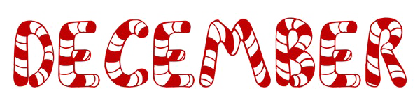

BOOK CLUB

**Book club meets the second and fourth Wednesday of every month at 3:00 at the library. Come join us!**

RENEW ONLINE

**Our automation allows you to search our collection. If you are a library patron you can also access your own account. You can reserve, renew and update your information. Go to our web page – www. newhall.lib.ia.us and click on the catalog tab. To access your account contact the library to see how easy it is to renew online.**

Check out our web page for the on-line adult catalog and kids catalog on the bottom left of the web page

[www.newhall.lib.ia.us](http://www.newhall.lib.ia.us)

FOLLOW US ON FACEBOOK

Newhall Public Library