New at the Library
DVD
Ordinary Angles

ADULT FICTION
Yesterday's Gone
When among crows
One of us knows
The family remains
Sleeping Giants
Twenty-seven minutes
I have some questions for you
When the world goes quiet
The paradise problem
You know what you did
The villa
The maidens
Zero days
None of this is true

BIOGRAPHY/REFERENCE
Talking on Eggshells Soft skills for hard conversations
Infectious Generosity

JUVENILE FICTION
The dare

JUVENILE NON-FICTION
If I ran the Horse show
Basketball's greatest players

CHILDREN
Monster Truck
Pete the cat wacky taco Tuesday
The truth about the couch
Dino-Earth Day
The Berenstain Bears' Big Book of Science and Nature
See you later, Alligator
Where's Bluey?

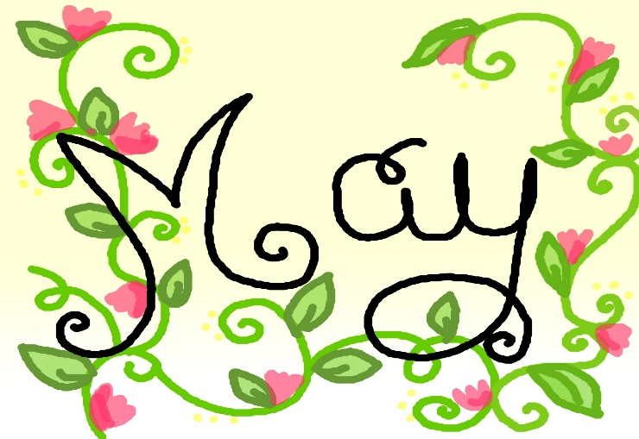

BOOK DISCUSSION GROUP
Our book discussion group meets the second and fourth Wednesday of every month at 2:30 at the library. Come join us!
RENEW ONLINE
Our automation allows you to search our collection. If you are a library patron you can also access your own account. You can reserve, renew and update your information. Go to our web page – www. newhall.lib.ia.us and click on the catalog tab. To access your account contact the library to see how easy it is to renew online.
Check out our web page for the on-line adult catalog and kids catalog on the bottom left of the web page
www.newhall.lib.ia.us

FOLLOW US ON FACEBOOK
Newhall Public Library

