|  |
| --- |
| New at the Library, July 2022 |

DVD

Moon Fall

Spiderman-No way home

Uncharted

Top Gun

The Marksman

Cyrano

The secret of Dumbledore

ADULT FICTION

The singing trees

Into the mist

Sparring partners

The whisper man

The end of her

The client

The runaway journey

The runaway wife

BIOGRAPHY/REFERENCE

Splendid and the vile

The choice

We the interwoven

God Bless this mess

JUVENILE FICTION

The field day from the Black Lagoon

The talent show from the Black Lagoon

The science fair from the Black Lagoon

The westing game

Family of liars

Good girls, bad blood

JUVENILE NON-FICTION

Fly Guy: Weird animals

CHILDREN

Little blue truck

Triceratops

The artist who painted a blue horse

Clifford goes to kindergarten

The smart cookie

Construction site mission: Demolition

Dr. Seuss: What pet should I get?

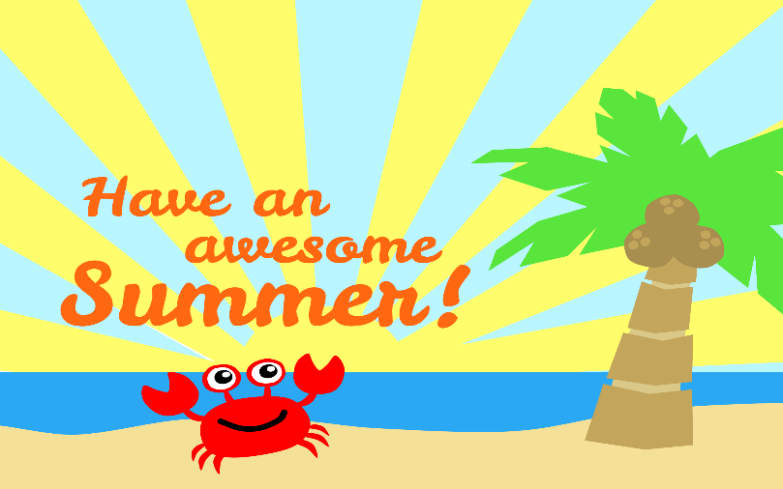

BOOK DISCUSSION GROUP

**Our book discussion group meets the second and fourth Wednesday of every month at 3:00 at the library. Come join us!**

RENEW ONLINE

**Our automation allows you to search our collection. If you are a library patron you can also access your own account. You can reserve, renew and update your information. Go to our web page – www. newhall.lib.ia.us and click on the catalog tab. To access your account contact the library to see how easy it is to renew online.**

Check out our web page for the on-line adult catalog and kids catalog on the bottom left of the web page

[www.newhall.lib.ia.us](http://www.newhall.lib.ia.us)

For more information on the summer reading program Follow us on Facebook or on our website!