|  |
| --- |
| New at the Library |

ADULT FICTION

Before you knew my name - Suspense

The truth about the accident - Suspense

The guest - Suspense

Village in the dark - Mystery

First Lie Wins - Suspense

The house of rust - Realistic Fiction

Mad Honey - Family

A court of silver flames - Fantasy

The spectacular - Historical Fiction

The manor house - Large Print - Suspense

BIOGRAPHY/REFERENCE

Good morning, monster-A therapist shares five heroic stories of emotional recovery

JUVENILE FICTION

The island-Suspense

The fury-Suspense

Nell of Gumbling #1 My extremely normal fairy-tale life - Graphic Novel

JUVENILE NON-FICTION

The indestructible Tom Crean Heroic explorer of the Antarctic

CHILDREN

Poke-a-dot! Old Mac Donald's Farm

Pinkalicious: Message in a bottle

St. Patrick’s Day

Gray fox in the night

Bluey: What games should we play?

Evergreen

The search for the giant arctic jellyfish

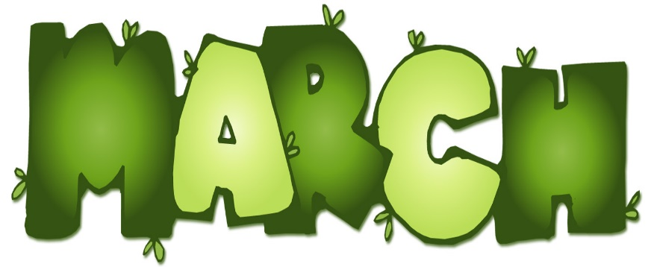

BOOK CLUB

**Our book discussion group meets the 2 nd and 4th Wednesday of every month at 3:00 at the library.**

**Come join us!**

RENEW ONLINE

**Our automation allows you to search our collection. If you are a library patron you can also access your own account. You can reserve, renew and update your information. Go to our web page – www. newhall.lib.ia.us and click on the catalog tab. To access your account contact the library to see how easy it is to renew online.**

Check out our web page for the on-line adult catalog and kids catalog on the bottom left of the web page

[www.newhall.lib.ia.us](http://www.newhall.lib.ia.us)

FOLLOW US ON FACEBOOK

Newhall Public Library